UFCFAF-30-3: TUTORIAL
Working with Gitlab and Sourcetree.

Version Controlling - Working with Gitlab and Sourcetree

Aim: The aim of this tutorial is to guide you through the initial steps of creating a Gitlab project and setting up a version control project using Source tree. In addition, the tutorial will guide you through the main stages of interacting with a Git-based project environment including creation of new resources, committing changes and pushing changed items to the version control server.
Background: In order to complete this tutorial, you should have access to Gitlab server, located at https://gitlab.com. Also, you might need to create an Atlassian account the very first time you open Sourcetree, or to use your Google account instead. (Skip steps 2-3 if you have done the setup of your project)

Task 1: Logging into UWE GitLab
- Go to the GitLab UWE site:
  - Open your browser and navigate to: https://gitlab.com (Figure 1)

- Log in:
  - Use your UWE credentials (username and password) to log in.
  - If this is your first time logging in, you may be prompted to confirm your email address and complete any additional registration steps.

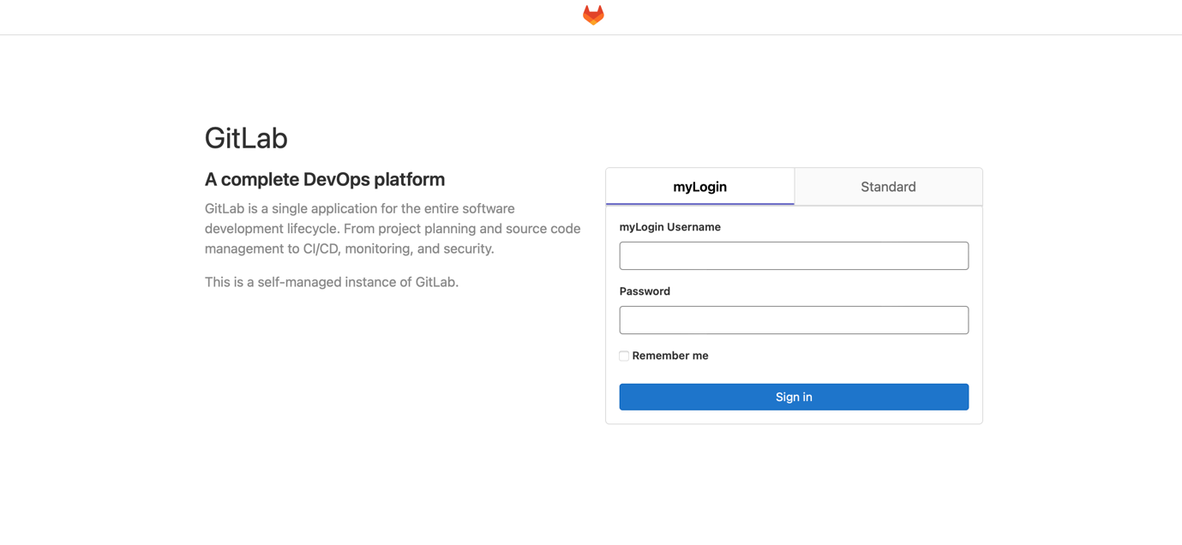
Figure 1: git login

Task 2: Create Project

- Creating a project:
  - Create a new project in Gitlab by clicking the relevant the option from the welcome page (Figure 2)

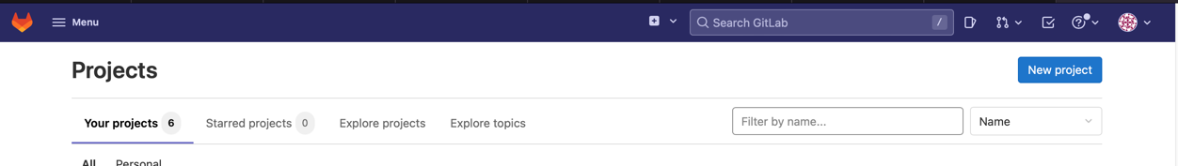
Figure 2: Creative Project
- Create a Blank Project (Figure 3), adding the relevant details as seen below such as, project name and description. Click on the option “Initialize repository with a README” and Make sure you select Visibility Level as Public! as seem below (Figure 4).

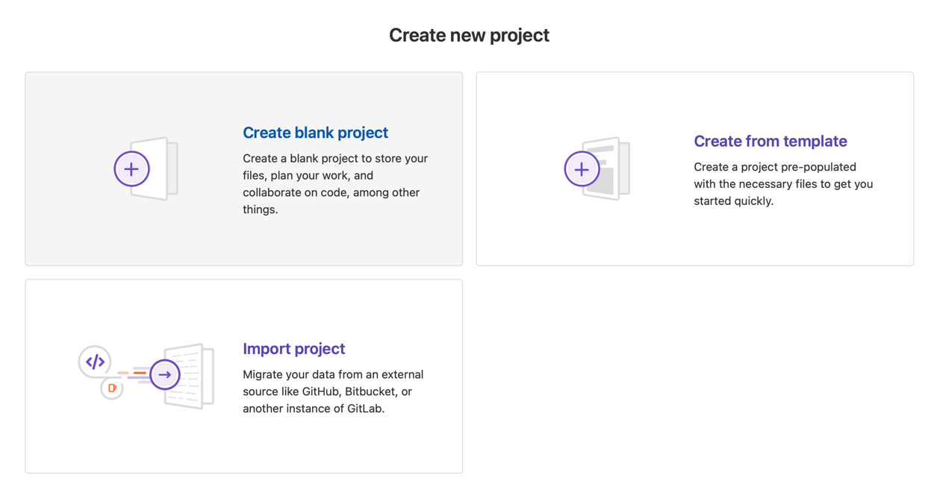
Figure 3: Create Blank Project

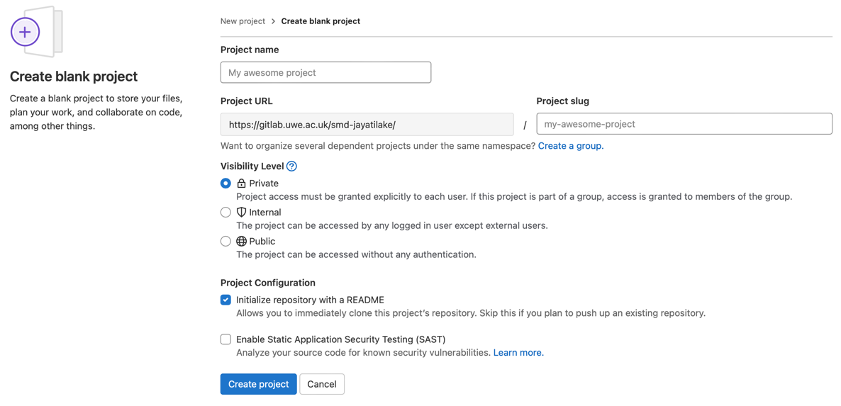
Figure 4: Set Visibility

Task 3: Setup Source tree

- Install Source Tree or any GIT client.
- IF you are using Sourcetree; goto: https://www.sourcetreeapp.com
- Run Source tree setup.
- You might be prompted to login using your git account

Task 4: Configuring GitLab to connect with source tree

- Configuring GIT server to accept client
  - Clock on the three dots on the top right corner.

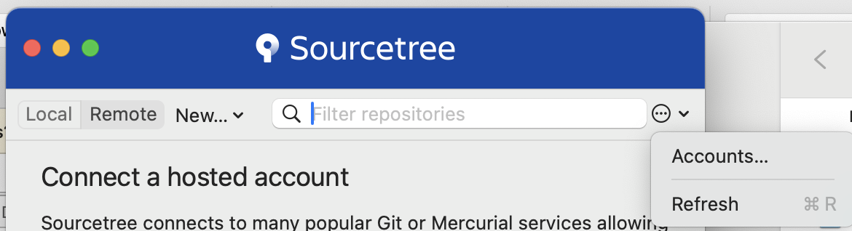
Figure 5 Source Tree Add Account

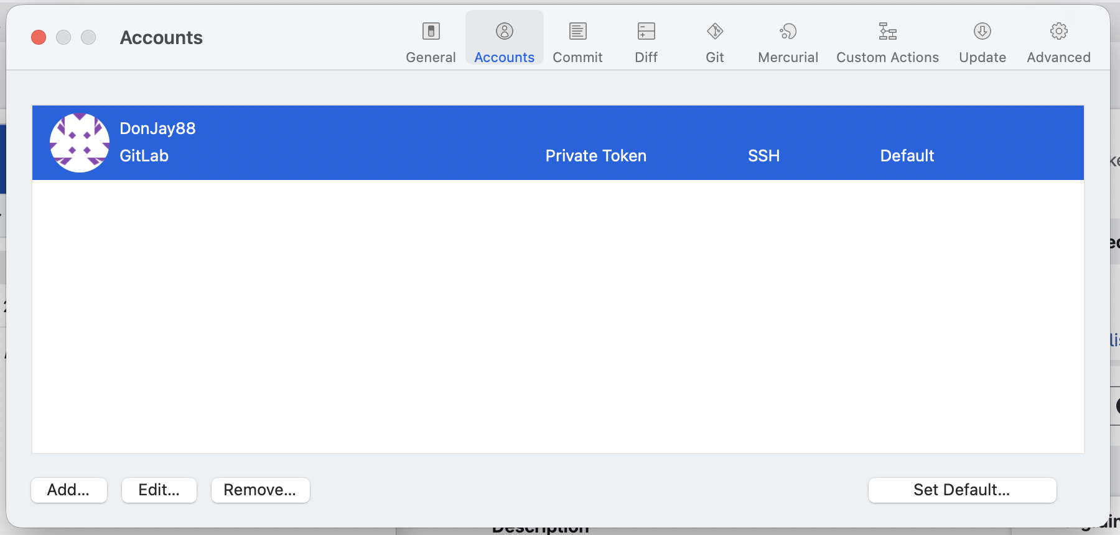
Figure 6 ST Add Account 1
  - Select Accounts (Figure 5)
  - Click on Add (Figure 6)
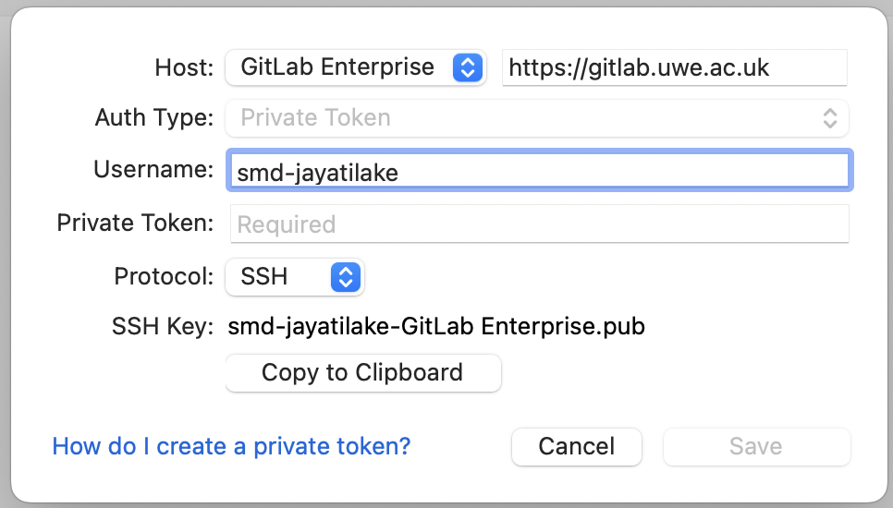
Figure 7 ST Account Access
  - Add Credentials (Figure 7)
    - Host: https://gitlab.uwe.ac.uk
    - Username: Your UWE username
    - Protocol: SSH
    - Copy SSH key by clicking “Copy to Clipboard”

  - Configure the repository SHH (Figure 8)
    - Go to your GitLab repository
    - Click on your avatar --> “Edit Profile”
    - Select SSH Keys --> Add new key
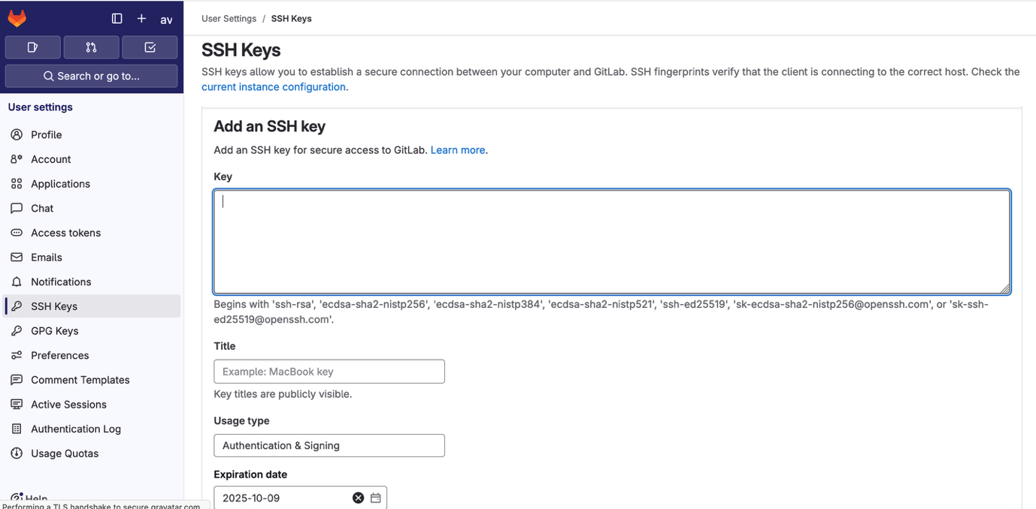
Figure 8 Add SSH Key
  - Configure the repository Personal Access Tokens (Figure 9)
    - Select “Personal Access Tokens” Add new token (Figure 9: Access Token)
    - Select “Legacy Tokaen” necessary scope for your account (Figure 10)
    - Click Create Personal Access Token
      - Copy the access token (Figure 11)

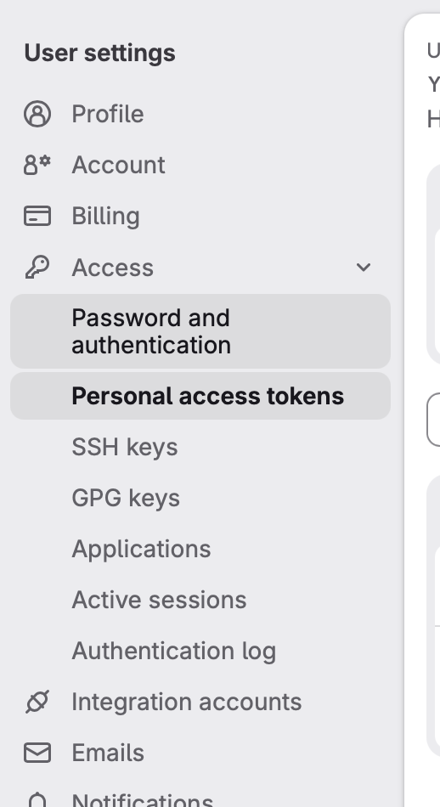
Figure 9: Access Token
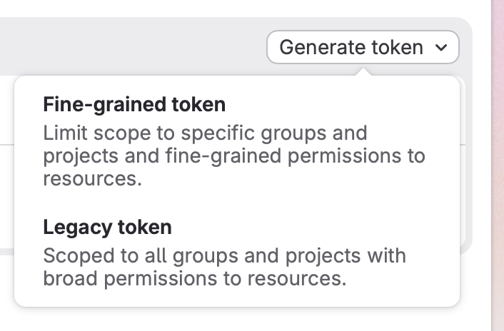
Figure 10 Token Type

Figure 11 Personal token
  - Add the Private Access token and complete your account.
  - Once its successful you will see all the remote repositories under your account

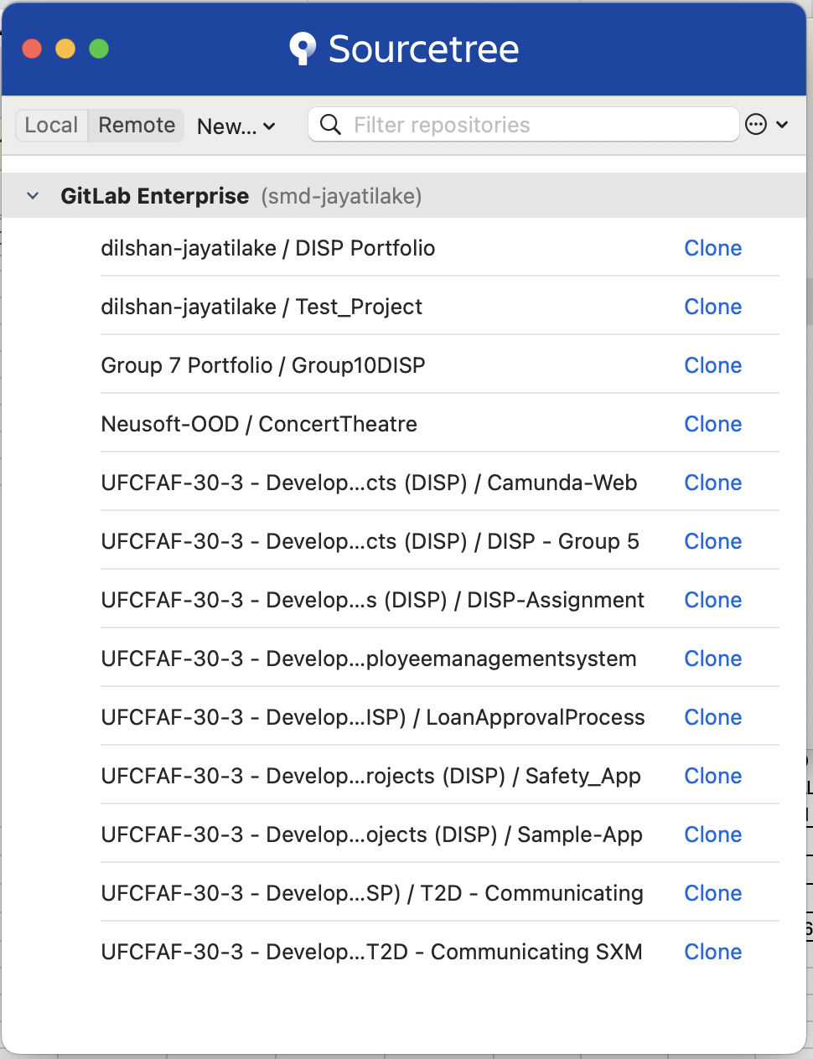

Task 4: Setting up remote repository with SourceTree

- Setting up
  - Once in Sourcetree environment, Select from the top left corner the option File-> New (Figure 12)
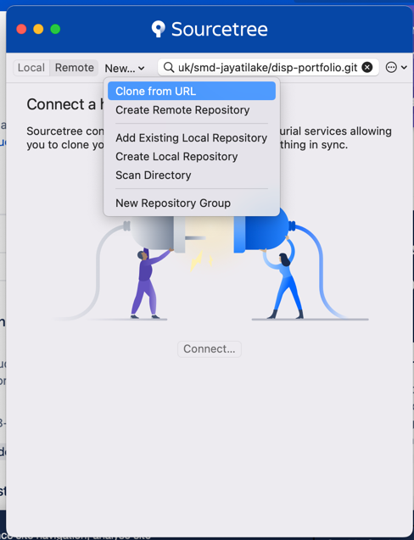
Figure 12: Add URL
- In the Source Path / URL field add the URL of your Gitlab project, eg https://gitlab.uwe.ac.uk/{username}/{projectname}, see example below(Figure 13).
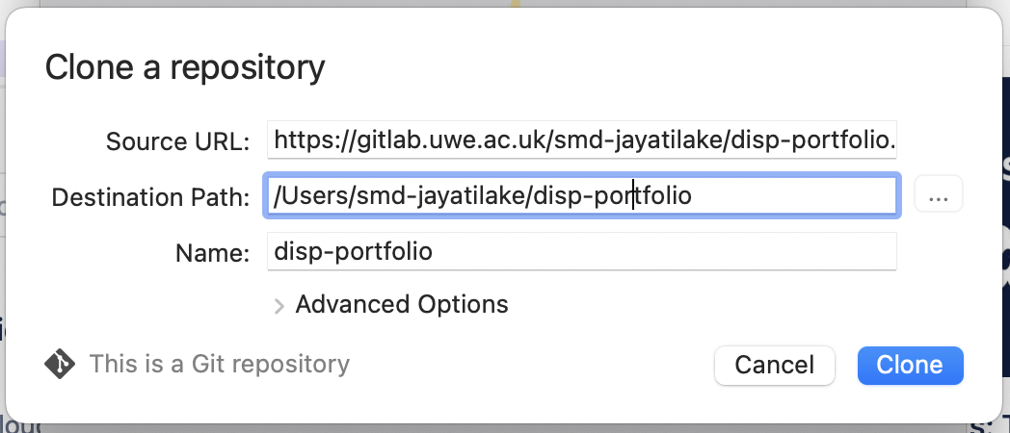
Figure 13: Add URL to project
- Click on the Clone button, you should now be in the main environment of the application.
- Check your local folder (project repository), should see a README file
- In case a README.md file wasn’t automatically created for you, use a text editor (Notepad++) and create a README.md file in the root your repository.
- Edit the README.md file and write a short description about the project, for example “This repository contains the components of the DISP Portfolio.”
- You can format the contents of a README file using Markdown syntax. For example, you can tag a Heading by using the Hash character e.g. # This is a title. A full reference of the Markdown syntax can be found at https://guides.github.com/features/mastering-markdown/
- In Sourcetree you should see that the changes on the README.md file are “known” and shown as upstaged, as seen below (Figure 7)
- Stage the file, and then write a commit message, something like “An initial edit to README” (Figure 15)
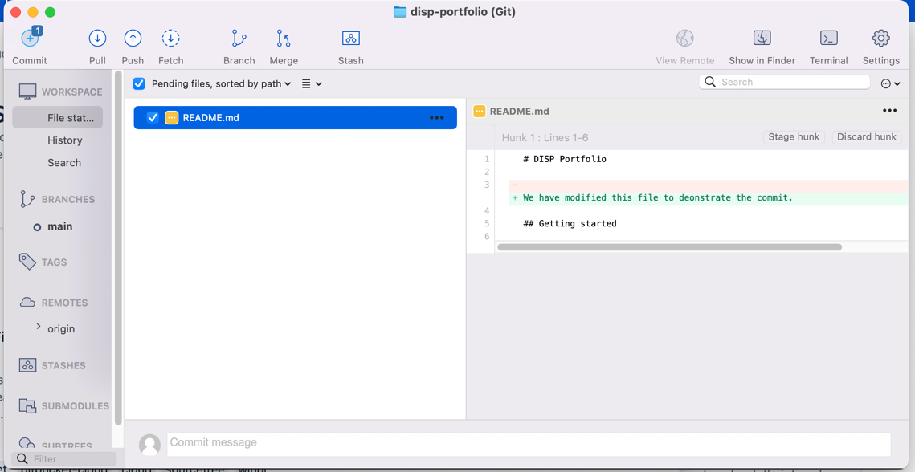
Figure 14: Stage
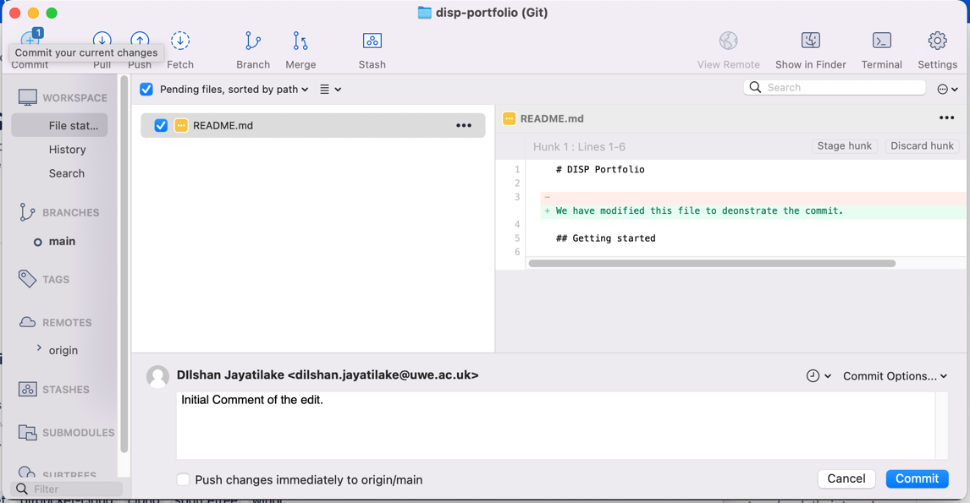
Figure 15: Commit
- Commit the changes, you should be able to see that the README.md file is shown committed and ready to be pushed on the remote repository.(Figure 16)
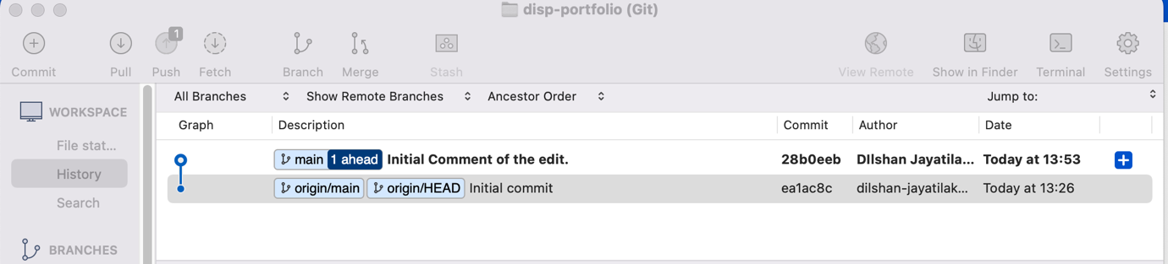
Figure 16: Commit on the local repo
- Now you are ready to push the changes to the remote server. Just press the Push button. (Figure 16)
- Select (in not already selected) the Remote branch to “master” click on the Push button (Figure 17)
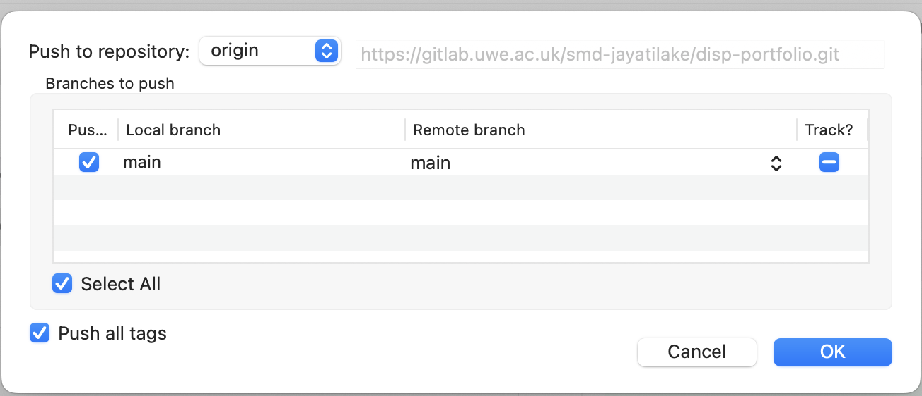
Figure 17: Push to remote server
- The file is now pushed on the remote server. Click on the master under BRANCHES, to view versioning of that branch, as seen below
- Go your Gitlab page to inspect the changes. See below

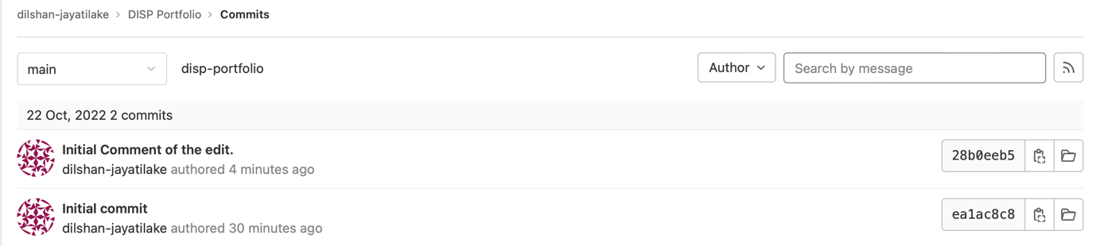
Figure 18: Commit in Git
- Now let’s create a new sub-directory in your local repository which is going to hold all the components of the first portfolio deliverable.
- Create the new sub-directory and give it the name “Enterprise Architecture”.
- Create a new word document and give a name, something along the line “Description of Enterprise and Information Systems.”
- Write a brief description (approx. 150-300 words) of the enterprise which you will employ in your portfolio and the role of the information systems to its operations.
- Stage the files in Sourcetree (Figure 19)
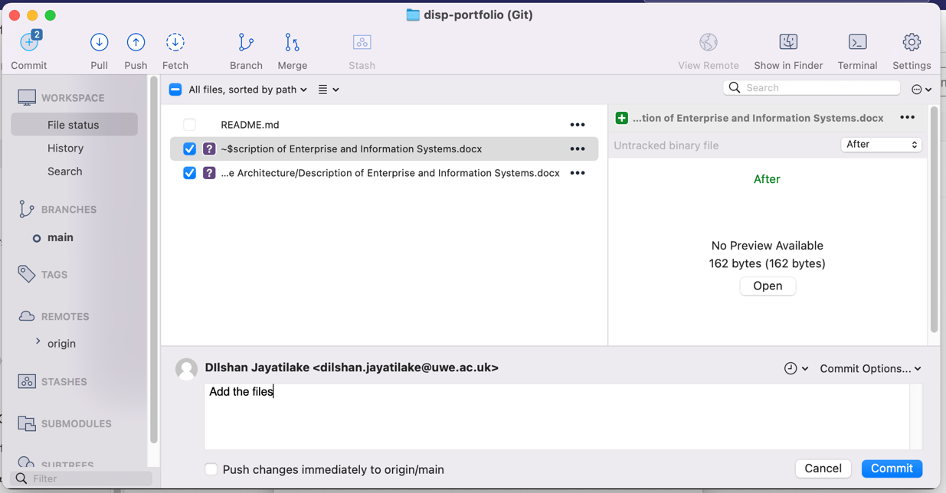
Figure 19: Stage Change
- Commit the changes
- Push changes to the remote server.
- It is a good practice to include a README.md file in the root of directories when it makes sense and seems useful. Since this new directory (Enterprise Architecture) is going to hold the components of a portfolio deliverable, it would useful to create a new README.md file with the following information.
“The directory contains a file of Zachaman Framework of Information Systems Architecture and a brief description of the enterprise and the role of the information systems”
- Your Gitlab directory should look like the image below. (Figure 20, Figure 21)
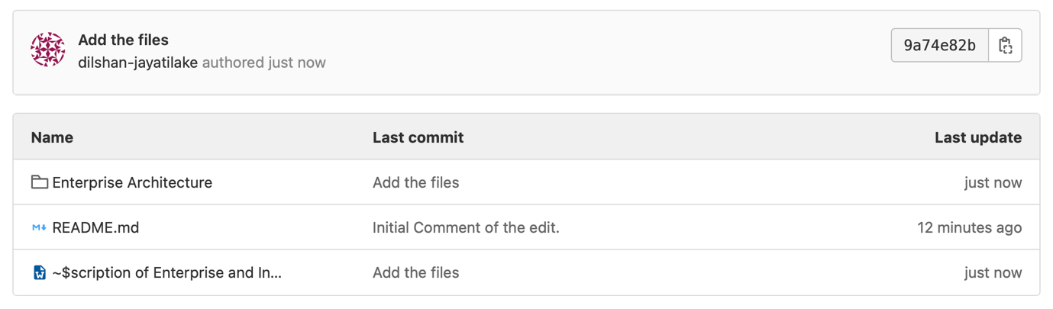
Figure 20: Repository after push
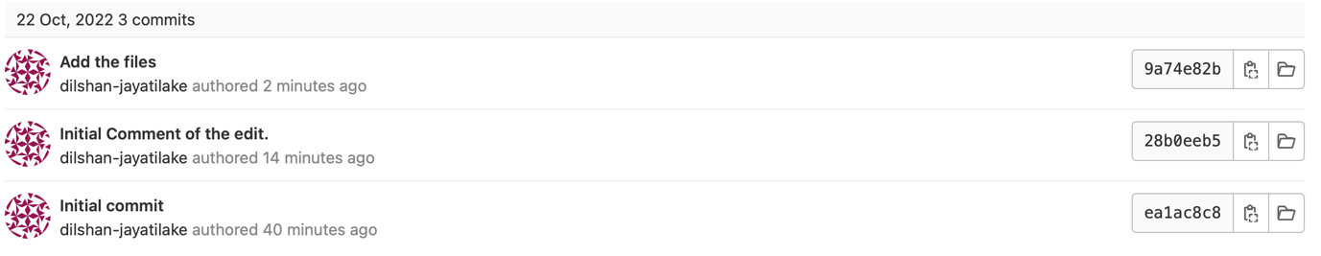
Figure 21: Commit History

